TASK 1

The task is to prepare a research document which includes: aim of the project, planning, risks involved, timeline and costs to develop a new mobile app for Greenwich University students to check attendance and grades.

**Project**: Develop a new mobile app for Greenwich University students to check attendance and grades.

1. **Purpose.**

* Currently, there are a lot of problems with the Greenwich University software in website **cms.greenwich.edu.vn**: the percentage of students absent from school shows up incorrectly, and also in the CMS software to submit papers. The school's assignment also calculates the percentage of plagiarism, which does not really affect the results and fairness for the students.
* So, our team implemented a project that aims to create a new piece of software for the University of Greenwich for the purpose of fixing the above problems but also upgrading and improving some of the new features to fit needs and uses of students and teachers.
* Total time to complete the product: **3 months**.

1. **Idea.**

**Project:** Develop a new mobile app for Greenwich University students to check attendance and grades.

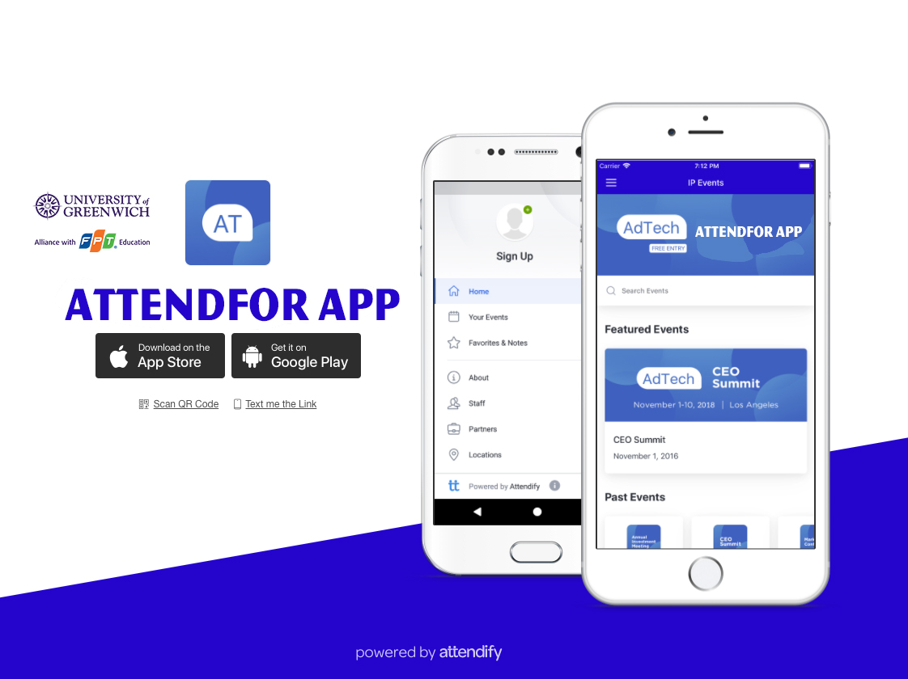**Mobile App name: “ATTENDFOR”**

**Feature of ATTENDFOR:**

* Attendance for students by artificial intelligence (AI): recognition of fingerprints and faces.
* Calculate algorithmically absent percentage.
* Assist teachers in assigning assignments.
* Show percentage of plagiarism and clearly identify the area in the plagiarized essay.
* Suggested assignment marking.

1. **Planning.**

**People:**

* Students, people with skills and passion for IT.
* 2 Technology engineers.
* 1 Manager.
* 2 people call the investment.

**Furniture:**

* Rent Clean office, have toilet.
* Buy Computers appropriate the needs of working.
* Rent Tables and chairs and equipment for working needs.

**Investor:**

* Director of Greenwich University.
* People want to invest.

**Timeline**

|  |  |
| --- | --- |
| **Milestone** | **Duration** |
| **Planning** | 11/11/2019 – 14/11/2019 |
| **Preparation** | 15/11/2019 – 24/11/2019 |
| **Implementation** | 25/11/2019 – 20/1/2020 |
| **Feedback** | 21/1/2020 – 31/1/2020 |
| **Review** | 01/2/2020 – 28/2/2020 |

1. **Risk involved.**

|  |  |  |  |  |
| --- | --- | --- | --- | --- |
| **Topic** | **Risk** | **Responsible by** | **Risk rating** | **Solution** |
| **Renting** | Rentals high | **Manager** | Medium | Negotiate with the landlord and discuss with them for a long-term lease (nearly 1 year). If no agreement is reached, find another rental location that is more suitable. |
| Broken tables and chairs | **Manager** | Low | Discuss with the lessor and offer compensation according to the contract. |
| **Computer** | Computer failure | **Manager, Staff** | Medium | Repair engraved at reputable computer stores and commit not to reveal customer information. |
| Lost data | **Manager, Staff** | Medium | Discuss with each other and proceed to fix the problem. |
| Information disclosure | **Staff** | Low | Remind and reprimand employees if recidivism is dismissed and dealt with according to law |
| **Salary** | The employee asked for a raise | **Manager** | Low | Encouraging and discussing with staff that this is a new project should face many difficulties with the expectation that everyone can work together to complete the request. |

1. **Cost.**

|  |  |
| --- | --- |
| **Project** | **Cost** |
| **Minimum Viable Product** |
| Discovery and Wireframing | $2,500 |
| App screen design | $3,500 |
| Root development on iOS | $37,000 |
| Root development on Android | $37,000 |
| Back-end programming, mechanical Database and API | $9,000 |
| Application Administration | $9,000 |
| Quality Assurance and Improvements on iOS | $5,000 |
| Quality Assurance and Improvements on Android | $5,000 |
| Deployment and Cloud | $2,000 |
| **TOTAL for product** | **$110,000** |
| **Renting** |  |
| Room | $1,000 |
| Tables and chairs | $100 |
| Equipment for working | $100 |
| **TOTAL per month** | **$1,200** |
| **TOTAL** | **$111,200** |